Cornell
After School

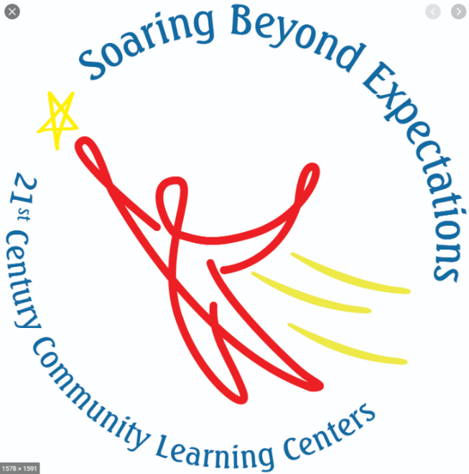

Nita M. Lowey 21st Century Community Learning Center

Annual Report 2019-2020

The Cornell After School program, in partnership with the Cornell School District, has been serving K – 8th grade students and their families for 19 years. It operates under the umbrella of the 21st Century Community Learning Center (CLC) and works collaboratively with Community Education, the Lake Holcombe After School program, and Love and Logic family program. The CLC programs receive funding through federal 21st Century Community Learning Center After School grants administered by the WI DPI, a Rutledge Charities grant, City of Cornell monies, Community Foundation of Chippewa County, class fees, and donations.
After School Mission

The mission of the Cornell After School program is to provide academic support, enrichment, and social development for children and their families after the school day has ended. We focus on strengthening academic achievement and social growth by offering unique learning opportunities in safe, enjoyable, and nurturing environments. Together with families, school, and community, we can help our children grow and develop into strong, responsible, caring citizens.

Vision and Values

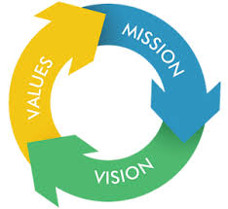
- Help Students Succeed at All Levels!
  - Academically
  - Socially
  - Emotionally
- Build Strong Connections!
  - Student to Student
  - Student to Adults
  - After School to Families
  - After School to Day School
  - After School to Community

After School and Covid - 19

The 2019 – 2020 school year will be remembered as the year Covid-19 hit. This pandemic had many devastating effects including all Wisconsin schools closing down on March 18th. The After School program closed. In addition, many of the CLC programs and activities were canceled including Community Ed spring classes and trips, the Family Fun Dance, and Outdoor Ed-venture.
In spite of the school doors being shuttered, the CLC staff continued to reach out and serve the Cornell after school students and families. Services and activities provided include virtual or on-line facilitated activities, phone calls, developed and distributed activity packets, distributed resource materials, and assisted with meal and food distribution for youth and families.

After School Staff

After School Team Members include Jenny Blaisdell - After School Coordinator / Family Education Director, Brandie Werlein - After School Site Coordinator, an Academic Success Coordinator, certified Cornell School District teachers, professional adult leaders, trained high school staff and community volunteers.

Advisory Committee

The Advisory Committee meets four times per year and is made up of school administrators, city officials, business leaders, parents, and community representatives. This committee monitors, assesses and provides feedback the CLC staff. They also serve as advocates for the CLC.
Current members include:

Brandie Werlein
Danielle Endvick
Dave DeJongh
Jenny Blaisdell
Judy Talbot
Kathleen Eddy
Kayla Olmstead
Kristine Hemenway
Kurt Lindau
Julie Kosher
Linda Bergen
Marilyn Murphy
Marty Timmerman
Michelle Wiensch
Mike Rivers
Nancy Glenzer
Paul Schley
Scott Bowe
Stephanie Seidlitz
Sue Howard
Wendy Mittermeyer

Partners

2019 – 2020 partners include but not limited to:
- Cornell Health Services
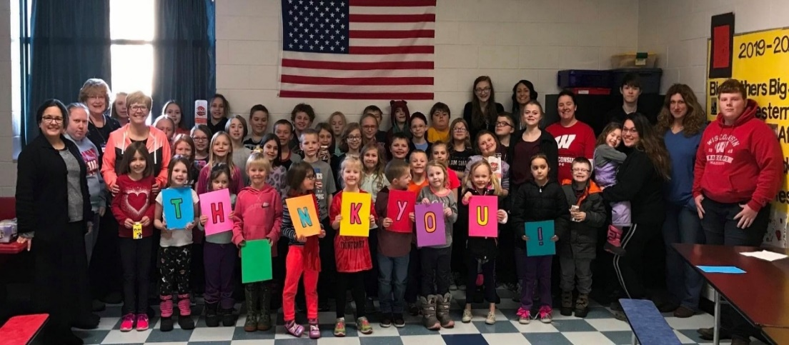
- Prevea
- Cornell PD
- Cornell Lions
- Camaraderie Club
- DNR
- Cornell Food Pantry
- Marshfield Clinic
- Northwestern Bank
- Community Foundation of Chippewa Co.
- UW-Extension
- United Commercial Travelers
- Family Support Center
- Thrivent
- Big Brothers/Sisters of Northwestern Wisconsin
- Citizens State Bank
- KJs Fresh Market

The After School program is very thankful for the support of so many organizations. Their involvement in the After School program gives students and families access to quality activities, resources and programming.
Enrollment and Attendance

- As of 3/18/20, 90 students were enrolled in the After School program.
- As of 3/18/20, 65 students were regular attendees (30 + days)
- As of 3/18/20, average daily attendance was 50 students.

Demographics of Regular Attendees

Number of Programming Days

- Program operates Monday – Thursday
- Program began on September 3, 2019
- 84 days through March 18, 2020

Daily Schedule

- School is dismissed

- 3:16 - 4:15: Skills and Studies – During this time, students will concentrate on academics and homework. Comprehensive one-on-one and small group tutoring will be available. Students are given an opportunity to work on their daily homework, projects, studying and the like with support from staff to strengthen their academic skills in Math, Reading, Writing, Science and Social Studies.

- 4:15 - 4:25: SNACK – Each student will receive a snack and milk. A wide variety of snacks are prepared by the schools’ food services department. This time is also used for encouraging friendships, creating an After-School family atmosphere and Character Building.

- 4:25 - 5:45: ACADEMIC ENRICHMENT – This period of the CLC program is designed to be a hands-on, fun, interactive learning experience. These activities are taught by After School Program staff as well as community volunteers and representatives of local and county agencies that partner with the program. This enrichment aligns with the school day curriculum & common core standards.

- 5:45-6:15: SPARK P.E & Power Up Your School. - SPARK is dedicated to creating, implementing, and evaluating research-based programs that promote lifelong wellness.

- After School ends

Goals and Objectives
Activities listed below are examples of but not all of the activities offered.

State Goal 1: Provide a stable, safe, and supportive environment to meet the needs of the target population.
- Local Goal: To provide a safe, stable, and supportive program including educational support to meet student need.
Expected Outcome #1:  By June 2020, 85% of regular CLC attendees and CLC staff will give a satisfactory or higher rating on the NYSAN self-assessment environment/climate section which includes factors such as safe program space, stimulating and supportive environment. | *Activities:  Developed safety plan, trained staff, conducted drills, monthly evaluations of space, and CLC staff and students surveyed. | Actual Outcome: MET  100% of CLC attendees and CLC staff that returned surveys gave a satisfactory or higher rating.
Expected Outcome #2:  By June 2020, 75% of CLC adult family members will give a satisfactory or higher rating on the NYSAN self-assessment environment/climate section which includes factors such as safe program space, stimulating and supportive environment. | Activities:  Safety plans shared with family members, Advisory Board input,  Family members surveyed | Actual Outcome: MET  100% of adult family members who responded to the survey gave a satisfactory or higher rating on the NYSAN.
- Local Goal #2: To provide services to welcome new students.
Expected Outcome #1:  By June 2020, 100% of CLC students new to the district will be partnered with a trained student buddy and a CLC staff member. | Activities:  Developed Buddy program, trained buddies and matched students, held Buddy events | Actual Outcome: MET  10 new CLC students were partnered with a trained buddy and staff member

State Goal 2: Challenge youth to develop as learners
- Local Goal #1: To improve student achievement in reading.
Expected Outcome #1:  By June 2020, 65% of regular CLC attendee who need to improve will increase their proficiency category in Reading. | Activities:  One on one or small group tutoring with Academic Liaison, variety of reading enrichment activities | Actual Outcome: MET  77% of regular CLC attendees increased their proficiency category
- Local Goal #2: To improve student achievement in math.
Expected Outcome #1:  By June 2020, 65% of regular CLC attendee who need to improve will increase their proficiency category in Math. | Activities:  One on one or small group tutoring with Academic Liaison, variety of math enrichment activities | Actual Outcome: MET  95% of those reported maintained or improved math proficiency.

State Goal 3: Support the development of other skills necessary for student success
- Local Goal #1: To provide students access to a broad array of programs and resources that focus on, but not limited to youth development, social emotional learning and AODA prevention.
Expected Outcome #1:  By June 2020, 75% of regular CLC attendees will report an increase in protective factors. | Activities:  Social/emotional lessons, guest speakers, service learning projects | Actual Outcome: MET  94% of regular CLC attendees responding to survey reported an increase in protective factors.
- Local Goal #2: To decrease behavioral referrals among regular attending CLC students.
Expected Outcome #1:  By June 2020, 65% of regular CLC attendees will decrease their behavioral referrals by 50%. | Activities: Social/emotional activities, small group guided meetings, consistent behavior policy | Actual Outcome: MET  71% of regular attendees decreased their referrals.

Goals and Objectives - continued

State Goal 4: Engage families in support of student learning.
- Local Goal #1: To strengthen adult family members’ connection to their child’s education.
Expected Outcome #1:  By June 2020, 65% of family members, who participated in three or more CLC family events will report an increase in knowledge about their child’s education which will result in a stronger connection between school and family. | Activities:  Showcases held with parent education lessons, family nights, partner with school and Community Ed to offer family focused activities and classes. | Actual Outcome: MET  100% of adult family members who returned survey reported an increase in knowledge.
- Local Goal #2: To provide resources and programs that meet family member learning needs.
Expected Outcome #1:  By June 2020, 70% of family members, who participated in three or more CLC events, feel they have gained knowledge of local resources and/or were helped by local resources. | Activities:  Resource Fair held, one on one resource referrals | Actual Outcome: MET  100% of adult family members who returned survey reported an increase in knowledge
Expected Outcome #2:  By June 2020, 100% of new to the district CLC student family members will receive a welcome resource packet and be matched with a mentor family if desired. | Activities:  Welcome bags offered at resource fair, student buddy training held & event attended by 21 matched students and 6 parents. | Actual Outcome: MET  100% of CLC families new to the district received welcome packets & buddy matches.
- Local Goal #3: To offer twice per year an extended family program that has evidence of effectiveness of AODA prevention.
Expected Outcome #1:  By June 2020, 75% of adult family members that participate in a 6 week CLC family program will increase knowledge of AODA issues and prevention. | Activities:  Two Love and Logic 6 week program held with emphasis on AODA issues | Actual Outcome: MET  100% of adult L&L participants increased knowledge of AODA issues and prevention.

Survey Results
DAY STAFF SURVEYS

PARENT SURVEYS
% of After School students that improved
or didn’t need to improve

Completing Class Class
Homework Participation Behavior
to Teacher
Satisfaction

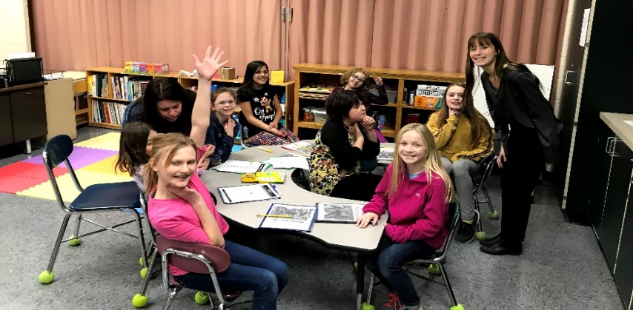
2019 – 2020 Highlights
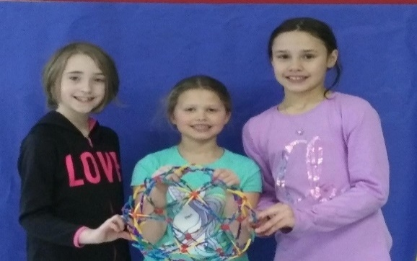

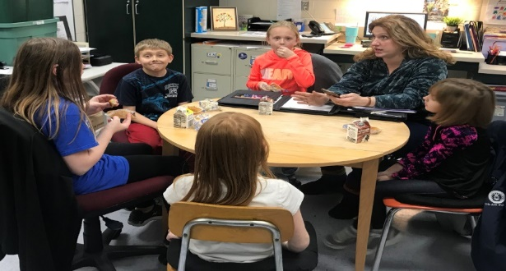
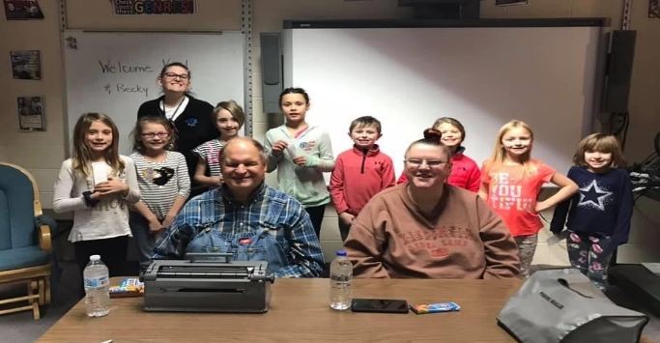
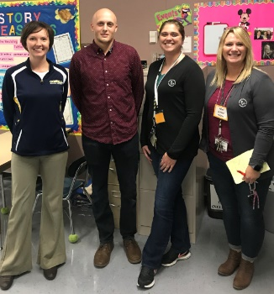
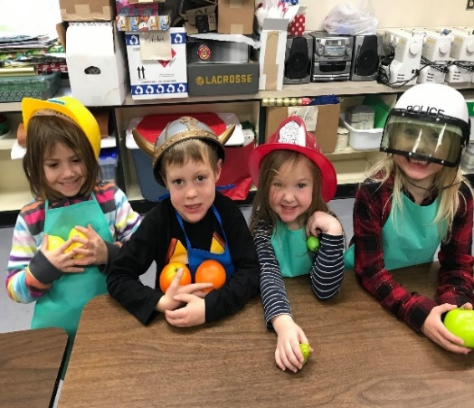
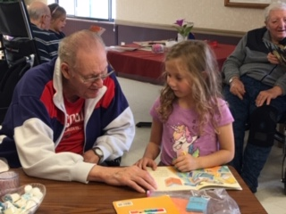
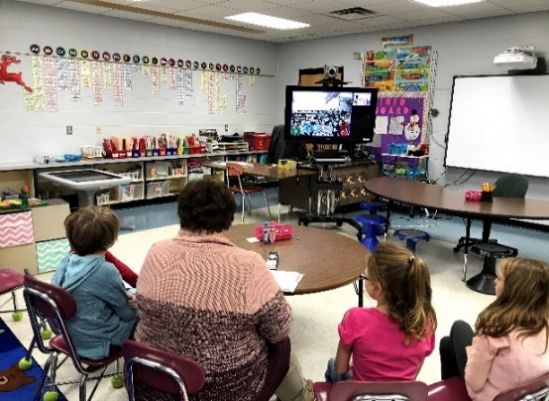
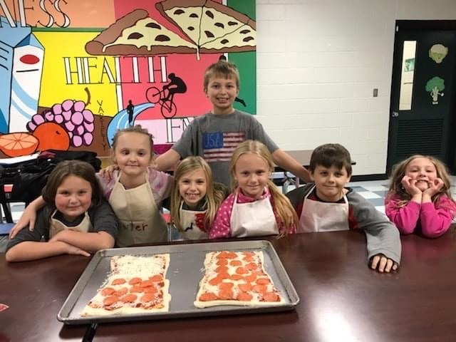
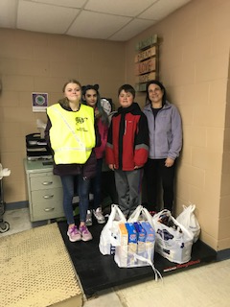
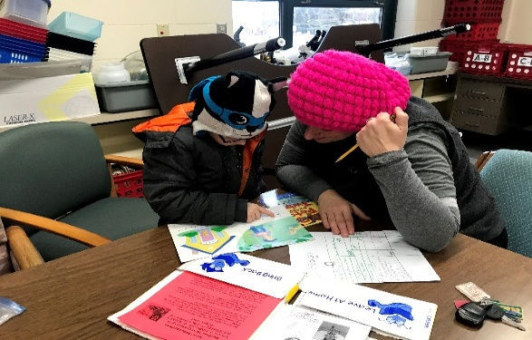
After-School Student Council
Community Guest Speakers
Mentoring Other Districts

New Student Buddies
Hands-On & Project-Based Learning
Cornell Health Services
SEL - Life Tools
Polycom connection
with Alaska
Service Learning
Multi-Grade Level Connections

Academic Advisor

