Cornell & Lake Holcombe

**Community**

**Education**

SPRING 2016

COURSE OFFERINGS

**Compliments of the**

**21st Century Community Learning Centers**

**Cornell and Lake Holcombe**

**Access this brochure anytime, anywhere by visiting our website at** [**www.communitylc.weebly.com**](http://www.communitylc.weebly.com)

**Click on the Community Education tab**

**Welcome to the Cornell/Lake Holcombe**

**Community Education Spring 2016 Catalog. This brochure contains information about upcoming classes and community activities. Community Education is a cooperative venture between the Cornell/Lake Holcombe 21st Century CLC’s, the school districts, Rutledge Charities, and the City of Cornell. Community Education is committed meeting community needs and sparking residents’ interests. Find an old favorite or something new and**

***ADD A LITTLE “CLASS” TO YOUR LIFE!***

**Cornell and Lake Holcombe Community Education**

**P.O. Box 517 Cornell, WI 54732**

**Check out our website!**

[**www.communitylc.weebly.com**](http://www.communitylc.weebly.com)

**Find us on Facebook!**

**Cornell & Lake Holcombe 21st Century Community Learning Centers**

**HOW TO REGISTER**

**Walk-In or Mail-In**

You may register in person Complete the Registration Form.

for all Community Ed classes *Make checks payable to:

by stopping by the Community  **Cornell / LH Community Ed**

Learning Center at Cornell *Mail Registration to:

Elementary School or at **Community Education**

Lake Holcombe Schools **P.O. Box 517**

**Cornell, WI 54732**

**Please register at least 1 week prior to the start of the class.**

*No confirmation of registration will be sent. If class is cancelled for any reason, you will be notified by phone and your money refunded. Once a class has begun, no refunds are permitted. Sorry, no refunds on trips.

**Need more info? Call Andrea Smith, Director**

**at (715)861-8011 or (715) 595-4241 ext. 249**

[**asmith@cornell.k12.wi.us**](mailto:asmith@cornell.k12.wi.us)

**Community Ed Registration Form**

**Name: ___________________________________________________________**

**Address: ________________________________________________________**

**Home Phone: ___________________ Cell Phone: _____________________**

**Email address: _______________________________________**

**C.E. Course Title(s):**

**1. _______________________________________________Fee: __________**

**2. _______________________________________________Fee: __________**

**3. _______________________________________________Fee: __________**

**___ Donate $5 to CLC Fund** (to help continue offering our programs) **__________**

**(Make checks payable to Cornell/LH Community Ed) Total: ____________**

**Community Ed Registration Form**

**Name: ___________________________________________________________**

**Address: ________________________________________________________**

**Home Phone: ___________________ Cell Phone: _____________________**

**Email address: _______________________________________**

**C.E. Course Title(s):**

**1. _______________________________________________Fee: __________**

**2. _______________________________________________Fee: __________**

**3. _______________________________________________Fee: __________**

**___ Donate $5 to CLC Fund** (to help continue offering our programs) **__________**

**(Make checks payable to Cornell/LH Community Ed) Total: ____________**

Special Events

**Parent University**

**Tuesday, March 8**

**5:15-8:00pm Lake Holcombe School**

This is a FREE family event and includes a meal for all and childcare for age 0-4 during the entire event. School-age kids will enjoy great activities while parents go to “class” on topics including:

* **Love & Logic**
* **Social Media-Beware!**
* **Working In Words**
* **Communicating w/kids**

**OUTDOOR “ED-VENTURE”**

**Sunday, May 1st 11am-2pm**

Cornell Mill Yard Park

Watch for flyers with more info!

**CELEBRATE SAFETY WEEK IN CORNELL MAY 9-13, 2016**

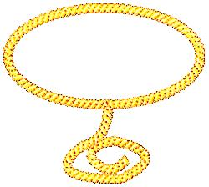

**Bike Rodeo &**

**GLOW RIDE**

**May 13th**

**Mill Yard Park**

* Obstacle Course
* Helmet Fitting
* Road Safety
* First Aid
* Glow Sticks for all!

Description: C:\Users\asmith\AppData\Local\Microsoft\Windows\Temporary Internet Files\Content.IE5\5WUV6GES\MC900133793[1].wmfDescription: C:\Users\asmith\AppData\Local\Microsoft\Windows\Temporary Internet Files\Content.IE5\5WUV6GES\MC900133793[1].wmf

Description: C:\Users\asmith\AppData\Local\Microsoft\Windows\Temporary Internet Files\Content.IE5\5WUV6GES\MC900133793[1].wmfDescription: C:\Users\asmith\AppData\Local\Microsoft\Windows\Temporary Internet Files\Content.IE5\5WUV6GES\MC900133793[1].wmf

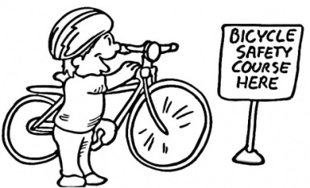

**ARTS & CRAFTS**

**Creating a S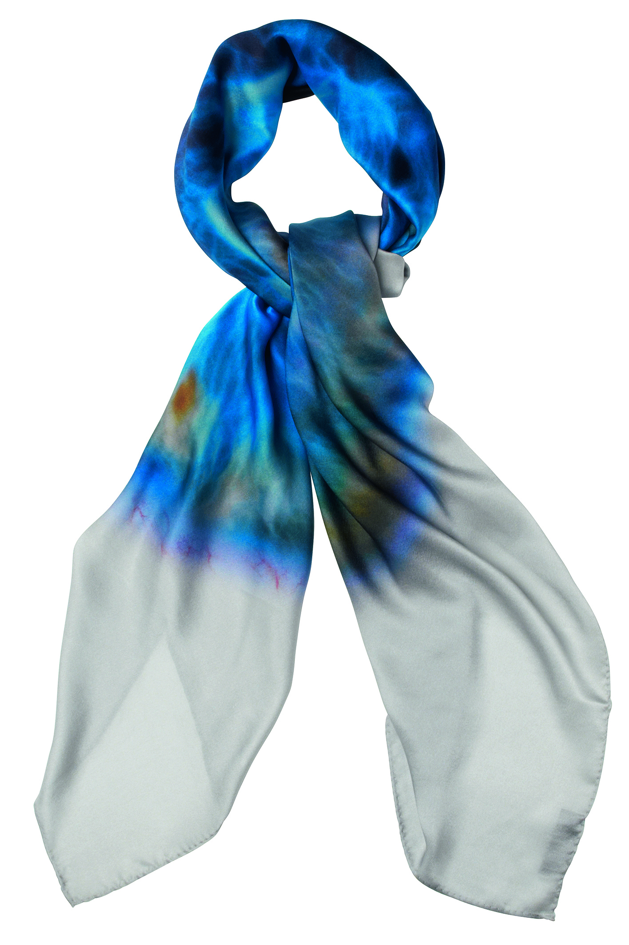ilk Scarf**

Create a gorgeous silk scarf using a variety of color hue dyes. Learn how to achieve different pattern and color effects and also have the opportunity to learn and apply a variety of techniques to achieve different textures. All participants will complete and take home their creation after class.

Two classes are offered and will take place at instructor, Linda Bergen’s home.

**Wednesday, March 9 1:00-3:00 or 6:00-8:00pm**

**Fee: $30 Linda Bergen’s Home**

**Wind Chimes**

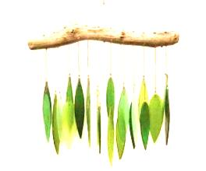Participants will have their choice of creating a wind chime from silverware, driftwood, or depression era plate and then add glass beads and stained glass. This project is one you’ll want to keep for yourself or give as a special gift. Cost is based on the materials you choose and is payable to instructor at the class. Please indicate class time choice on registration form.

**Wednesday, March 23 9:00am-noon or 6:00-9:00pm**

**Fee: $20-$35** (pay instructor day of class) **Linda Bergen’s Home**

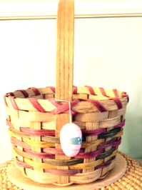

**Dressed Up for Easter**

This cute little basket is perfect for the children to carry on their Easter egg hunt or as a centerpiece on your table. It measures 5 ½” in diameter and 8” tall with the handle. This is fun for all levels of weavers, new and seasoned!

**Supplies to bring to class: Dish pan, towel, spray bottle, tape measure, pencil, clip clothes pins, flat screwdriver.**

**Thursday, March 24 5:00-9:00pm**

**Fee: $35 Cornell High School Commons**

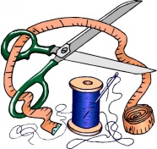

**Sewing Group**

Are you new to sewing? Do you just want to spend time with

others doing what you love? A sewing group could be the perfect place for you. Enjoy a cup of coffee and some conversation while working on your sewing projects in the company of other crafters. Share ideas and watch the progress of each project from week to week.

**Wednesdays 9:00-11:00am**

**Fee: FREE Cornell Elementary School**

**SAFTEY COURSES**

#### http://img1.123freevectors.com/wp-content/uploads/great/heart-beat-free-vector-609.jpgMCj03520980000[1][Basic Life Support](http://cpr.heart.org/AHAECC/CPRAndECC/Training/HealthcareProfessional/BasicLifeSupportBLS/UCM_473189_Basic-Life-Support-BLS.jsp)

Basic Life Support training reinforces healthcare professionals’ understanding of the importance of early

CPR and defibrillation, basic steps of performing CPR, relieving choking, and using an AED; and the role of each

link in the Chain of Survival. Three separate dates are available as class is limited to 6 participants each.

Classes are led by American Heart Association Instructor, Tim Ruhde.

Please indicate choice of class date on registration form.

**March 15, April 19 or 28 5:30-9:30pm**

**Fee: $55 (includes book) Lake Holcombe School**

**j0156091%5b1%5dATV Safety**

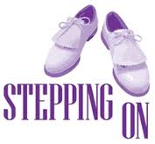This course is designed to reduce the potential for ATV accidents, injuries and fatalities and emphasizes the importance of laws, ethics, personal safety and proper use. Anyone who operates an ATV on public riding areas who is at least age 12 years of age must have completed a safety certification course. For children under 12 years of age, the certificate

does not become valid until the child reaches 12.

All students are required to obtain a WI DNR Customer ID Number before the completion of

this class and will also be required to provide that ID Number to the instructor. To obtain an ID

call the WI DNR Customer Service at 1-888-936-7463 or online at: [www.dnr.state.wi.us](http://www.dnr.state.wi.us).

**Please pre-register with Community Ed at least one week in advance!**

**March 28, 30, 31 4:00-7:00pm**

**Fee: $12**  **Cornell High School**

# Heartsaver® Courses

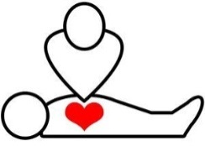Heartsaver® courses are for anyone with limited or no medical training who needs a course completion card for job, regulatory or other requirements. These courses are also designed to meet OSHA requirements. A course completion card, valid for two years, is issued upon completion. This is a two-session course with several

dates to choose from. Limit 6 per class. Please indicate date preference on registration. Classes are led by American Heart Association Instructor, Tim Ruhde.

**April 6 & 7 or April 12 & 13 5:30-9:30pm**

**Fee: $50 (includes book) Lake Holcombe School**

**SAFTEY COURSES (CONTINUED)**

**Boater’s Safety**

Recreational boating use on our waterways has grown tremendously over the past decade. It is increasingly important for boaters to become educated on safe boating techniques and laws. This DNR safety course can help ensure healthy, happy and safe voyages for

years to come. Anyone 10 years of age and older is eligible to take this course

and receive a safety certificate, however, the certificate does not become valid

until 12 years of age

**Please pre-register with Community Ed at least one week in advance!**

**April 25, 26, & 27 4:00-7:00pm**

**Fee: $12 Cornell High School**

**ADULTS/SENIOR CITIZENS**

**Stepping On**

**Falls Prevention Workshop**

This 7 week workshop builds confidence and reduces falls! Meet with physical therapists, vision and medication experts. Leave with more strength, balance and confidence. Space is limited!

**To register please call (715) 726-7777 by March 14, 2016**

Sponsored by Mayo Clinic Health Systems and Cornell Area Care Center

**Wednesdays, March 30-May 11 1:00-3:00pm**

**Fee: FREE Cornell Elementary School**

 **Camaraderie Club**

The name says it all! This very friendly and active group of adults meets every Monday morning for coffee, conversation and camaraderie! Something new is offered each week including information on hot topics, craft activities, guest speakers, games, and cards. Join us anytime…no membership required!

**Mondays Cornell Elementary School**

**Fee: FREE 9:00-11:00am**

**KIDS CLASSES**

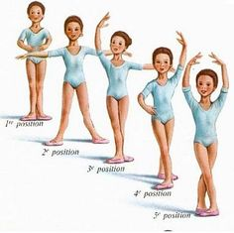**Beginners & Basic Ballet**

This class for boys and girls **ages 3-6** is designed to inspire, educate and stimulate the creativity of young dancers and to foster the love for movement. Dancers will be taught basic ballet moves and dances through age-appropriate music. Girls will need ballet leotard and boys will need shorts and t-shirt; ballet shoes are recommended. Children will showcase what they’ve learned during a spring dance recital. Stephanie Seidlitz and Jessica Hilger instruct. **NOTE: Registration will take place on Friday, March 11 from 4-7pm at Cornell Elementary Commons**

**Saturdays, March 26 thru May 7 9:00-9:30am**

**Fee: $35** (pay instructor) **Cornell Elementary School**

**The World of Dance**

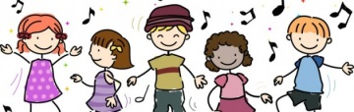This combination class for **kids age** **7-12** includes jazz, ballet, hip hop and contemporary. Class is designed to teach children the art of dance and movement in a fun and disciplined setting. All dancers will have the opportunity to perform on stage at our recital for family and friends. Girls will need a ballet leotard and boys will need shorts and t-shirt. Ballet shoes as well as athletic shoes are also required. Stephanie Seidlitz and Jessica Hilger instruct. **NOTE: Registration will take place on Friday, March 11 from 4-7pm at Cornell Elementary Commons**

**Saturdays, March 26 thru May 7 9:45-10:45am**

**Fee: $45** (pay instructor) **Cornell Elementary School**

**Cheers Pablo-**

**Remote Painting Party**

Come and enjoy the one-of-a-kind Cheers Pablo experience! No painting experience? No worries. Our fun and engaging artist instructors are the best in the business. Instructors guide you step-by-step through the featured painting, ensuring you stay on track to complete your 16”x20” masterpiece by the end of session. You can follow the artist's lead or uncork your inner Picasso and add your own flair and twist on colors. Kids will be painting “Climbing Pinwheels” in this one-session class.

**Wednesday, March 30 3:30-5:30pm KIDS** (age 5-12)

**Fee: $25 Holcombe School Art Room**

**HEALTH & FITNESS**

**Thai Cooking**

Thai cooking is simple, fun and creative! Learn to cook fresh, delicious Thai dishes in this class led by Terri Wilson, owner of *Mahli Thai* *Asian Cuisine* in Chippewa Falls. Classes are a combination of hands-on and demonstration where participants will enjoy creating and savoring the following: Shrimp & pork wonton dumpling, Red Curry Chicken lab (salad), Pad Thai, Mango Sticky Rice and more. Bring your appetite! Two classes are offered and limited to 10 students.

*Please indicate class date choice on registration.

**Monday, March 21 Lake Holcombe School 5:00-8:00pm**

**Monday, April 4 Cornell High School 5:00-8:00pm**

**Fee: $30 per person Max: 10 students per class**

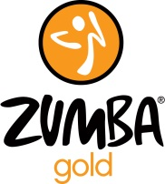

**Zumba Gold**

Zumba Gold is designed for older adults who want to remain active or for those who are just beginning a fitness program. This is a low-impact class using Latin music and rhythms. It's the perfect combo of fun and fitness. Be sure to bring water and wear comfortable shoes and clothing. Gym membership is not required and fees are payable directly to instructor, Kate Elling.

Class is underway NOW so join any time!

**Tuesdays** **4:30-5:30pm**

**Saturdays 8:30-9:30am**

**Fee: $5/class or $20/5 punch card Magic Salon, Holcombe**

**MMj02362130000[1]**

**Open Walking**

The Cornell Elementary School gym and Lake Holcombe gym are open now for

walking exercise. Join fellow walkers in a safe, element-free environment.

This is a great opportunity for post-op patients to build up endurance and a

healthy way to lose pounds sensibly for those who prefer a low-impact exercise regimen. Participants must wear tennis shoes. No walking on non-school days.

**Weekdays (Cornell Elem Gym) 8:00-9:00am**

**Weekdays (Lake Holcombe) 8:30-9:30am**

**Fee: FREE**

**ARTS & CRAFTS (CONTINUED)**

**Cheers Pablo-**

**Remote Painting Party**

Come and enjoy the one-of-a-kind Cheers Pablo experience! No painting experience? No worries. Our fun and engaging artist instructors are the best in the business. Instructors guide you step-by-step through the featured painting, ensuring you stay on track to complete your 16”x20” masterpiece by the end of session. You can follow the artist's lead or uncork your inner Picasso and add your own flair and twist on colors.

Adults will paint “Sunflowers” in this one-session class.

**Wednesday, March 30 6:00-8:30pm ADULTS** (age 13+)

**Fee: $35 Holcombe School Art Room**

**Mosaic Stepping Stones**

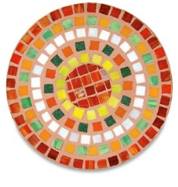Participants in this class will construct a gorgeous mosaic stepping stone using stained glass. We’ll learn to cut and grind glass, nip glass pieces, and adhere to a 12”x12” concrete base. All materials will be supplied by instructor, Linda Bergen, who will also grout and seal the finished project. Instructor has all the equipment needed and provides materials.

**Wednesday, April 20 9:00am-1:00pm**

**Fee: $45 Linda Bergen’s Home**

**Double Handle Carrier**

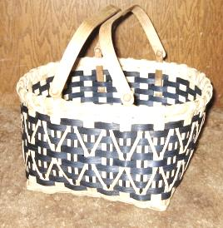This is a nice size basket for gardening or holding your handwork projects. It is easy to weave and will have everyone impressed! This basket accommodates a wood shelf (additional fee) ideal for carrying two separate pies or items for a potluck. It measures 13”x14”x8” tall, not including the oak swing handles. All levels of weavers will enjoy this. **Supplies to bring to class: Dish pan, towel, spray bottle, tape measure, pencil, clip clothes pins, flat screwdriver.**

**Thursday, April 21 5:00-9:00pm**

**Fee: $45 Cornell High School Commons**

**FAMILY**

**Building with Boys**

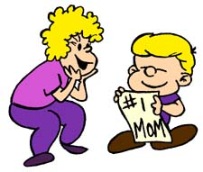Hey boys, don’t leave Mom behind!

Show her that you still enjoy having fun with her by inviting her to build some cool things with you! We’ll assemble wooden airplanes and then a wooden toolbox, complete with your name engraved on it. We can’t end this event without dessert! Treat your favorite lady to some dirt cake, complete with worms!

This event is for boys age 4-14 and their mom, grandma, aunt or other female chaperone. Limit: 30 participants

**Tuesday, March 29 5:30-7:30pm**

**Fee: $15/couple Lake Holcombe School**

$10 each additional child; maximum 2 children per adult

**Parenting the “Love and Logic”™ Way**

Love and Logic changes lives. Practical skills parents can use immediately bring the joy and fun back to parenting. This "how-to" approach is easy to learn, effective, powerful, and lasting. "Parenting the Love and Logic Way" has been helping families prosper for over four decades. As we laugh together at ourselves and the ups and downs of parenting, we will learn what it takes to raise respectful, responsible kids who are fun to be around.

**Free child care is available**.

**Mons & Wed. April 4, 6, 11, 13, 18, & 20 6:00-7:30pm**

**Fee: $30 per family Lake Holcombe School**

**(Fee is for all SIX SESSSIONS and includes one workbook, a $10 value)**

Fun Facts!

* Strawberries have more Vitamin C than oranges
* A person speaks about 4800 words a day
* Baby robins eat 14 feet of earthworms every day!
* There’s 293 different ways to make change for just one dollar
* The average human dream lasts only 2 to 3 seconds